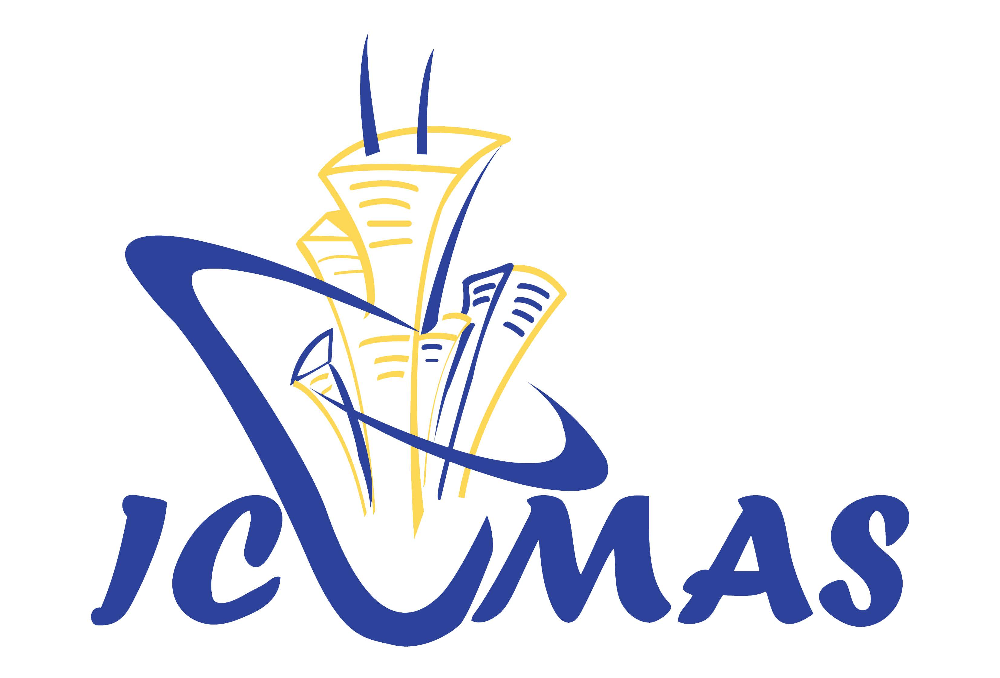
Registration Form
 | Conference Rate for the 5th ICUMAS 2017
Registration | Conference Rate
Day 1 Conference  30 March 2017 | HK$ 2,500 / US$ 320 (lunch included)
Day 2 Conference  31 March 2017 | HK$ 2,500 / US$ 320 (lunch included)
Day 1 + Day 2 Conference | HK$ 3,400 / US$ 430 (lunch included)
Registration fee includes ICUMAS and copy of conference proceedings | Total HK$ / US$
* 20% discount for delegates of 5 or above
* 10% discount for members of co-organizers and supporting organizations
* 20% discount for students (Full Day Conference) / 50% discount for students (without lunch)
Sponsorship for Advertisement  (ICUMAS Proceedings)  贊助場刊 | 封底 Back Cover for US$1,900 / HK$15,000
 | 封二、前扉 Inside Front Cover / Front Title Page for US$1,550 / HK$12,000
 | 封三、後扉 Inside Back Cover / Back Title Page for US$1,280 / HK$10,000
 | 跨頁 Inside two Pages for US$1,900 / HK$15,000
 | 內頁 Inside Pages for US$640 / HK$5,000 per page
Sponsorship (Others)  其他贊助 | 金額 Amount:

Delegate Details
Company / Organization:
Contact Person: | Title: Prof. / Dr. / Ir / Sr / Mr. / Mrs. / Ms.
Full Name (English)
Full Name (Chinese if applicable)
Position:
Address:
City: | Country: | Post Code:
Phone: | Fax: | E-mail:
Other Delegates
Payment Method
- By Cheque
Please submit the filled registration form with a local Hong Kong Cheque (No.: __________ / Bank: _______________) made payable to “HONG KONG INSTITUTE OF UTILITY SPECIALISTS”, and mail to Conference Secretariat, MES Services Limited,
Unit 209, Favor Industrial Centre, 2-6 Kin Hong Street, Kwai Chung, New Territories, Hong Kong SAR, People’s Republic of China.
- Telegraphic Transfer
Name of Bank: Bank of China (Hong Kong) Limited 中國銀行（香港）
Name of Account: HONG KONG INSTITUTE OF UTILITY SPECIALISTS
Account No: 012-565-00014068 (港幣HKD)
SWIFT CODE: BKCHHKHHXXX
3. ALIPAY Transfer支付寶
Account: mes.services.ltd@gmail.com/852-92294114

For any enquiry, please call ICUMAS Conference Secretariat, MES Services Limited (852) 3188 5230 or email to icumas@hkius.org.hk
China Mobile: 1314 396 8154 Website: www.hkius.org.hk

