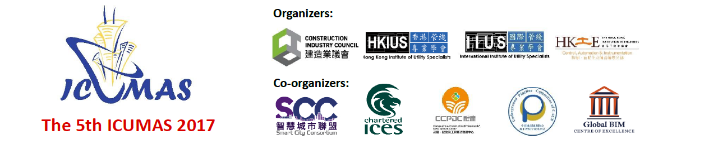

Reply Slip
Sponsorship & Advertisement
The 5th ICUMAS 2017
(ICUMAS | 29-31 March 2017 | Hong Kong)

Company Information
Company / Organization:
Contact Person: |  | Prof. / Dr. / Ir / Sr / Mr. / Mrs. / Ms.
Position:
Address:
City: |  | Country: |  | Post Code:
Phone: |  | Fax: |  | E-mail:
Please select where appropriate:
Sponsorship Package Options: |  |  | Advertising Options:
Title Sponsor: | □ HK$200,000 |  | Back Cover: |  | □ HK$15,000
Platinum Sponsor: | □ HK$50,000 |  | Inside Back: |  | □ HK$10,000
Gold Sponsor: | □ HK$30,000 |  | Inside Double-page Spread: |  | □ HK$15,000
Silver Sponsor: | □ HK$20,000 |  | Inside Full Page of A4: |  | □ HK$5,000
 |  |  | Exhibition Counter |  | □ HK$8,000
Others (please specify the amount or any other sponsorship methods you prefer):

Payment Method
By Cheque:

Please submit the filled reply slip with a local Hong Kong Cheque (No.: __________________ / Bank: _______________) made payable to “HONG KONG INSTITUTE OF UTILITY SPECIALISTS”, and mail to Conference Secretariat, MES Services Limited, Unit 209, Favor Industrial Centre, 2-6 Kin Hong Street,
Kwai Chung, New Territories, Hong Kong SAR, People’s Republic of China

Bank Deposit:
Name of Bank: Bank of China (Hong Kong) Limited 中國銀行 (香港)
Name of Account: HONG KONG INSTITUTE OF UTILITY SPECIALISTS
Account No: 012-565-0-001406-8 (港幣HKD)

* Please complete and return this reply slip by post, fax or email to:

ICUMAS2017 - Conference Secretariat, MES Services Limited
Address: Unit 209, Favor Industrial Centre, 2-6 Kin Hong Street, Kwai Chung, New Territories, Hong Kong SAR, People’s Republic of China Website: www.hkius.org.hk
Tel: (852) 3188 5230 Fax: (852) 2367 5964 Email: enquiry@hkius.org.hk

